|  |
| --- |
| Prepared exclusively for:  Town of Chilmark, MA. |
| Menemsha Beach Wi-Fi Trial  TelecomTrash Stations |
| April 12th , 2016 |
| Confidential and proprietary. |

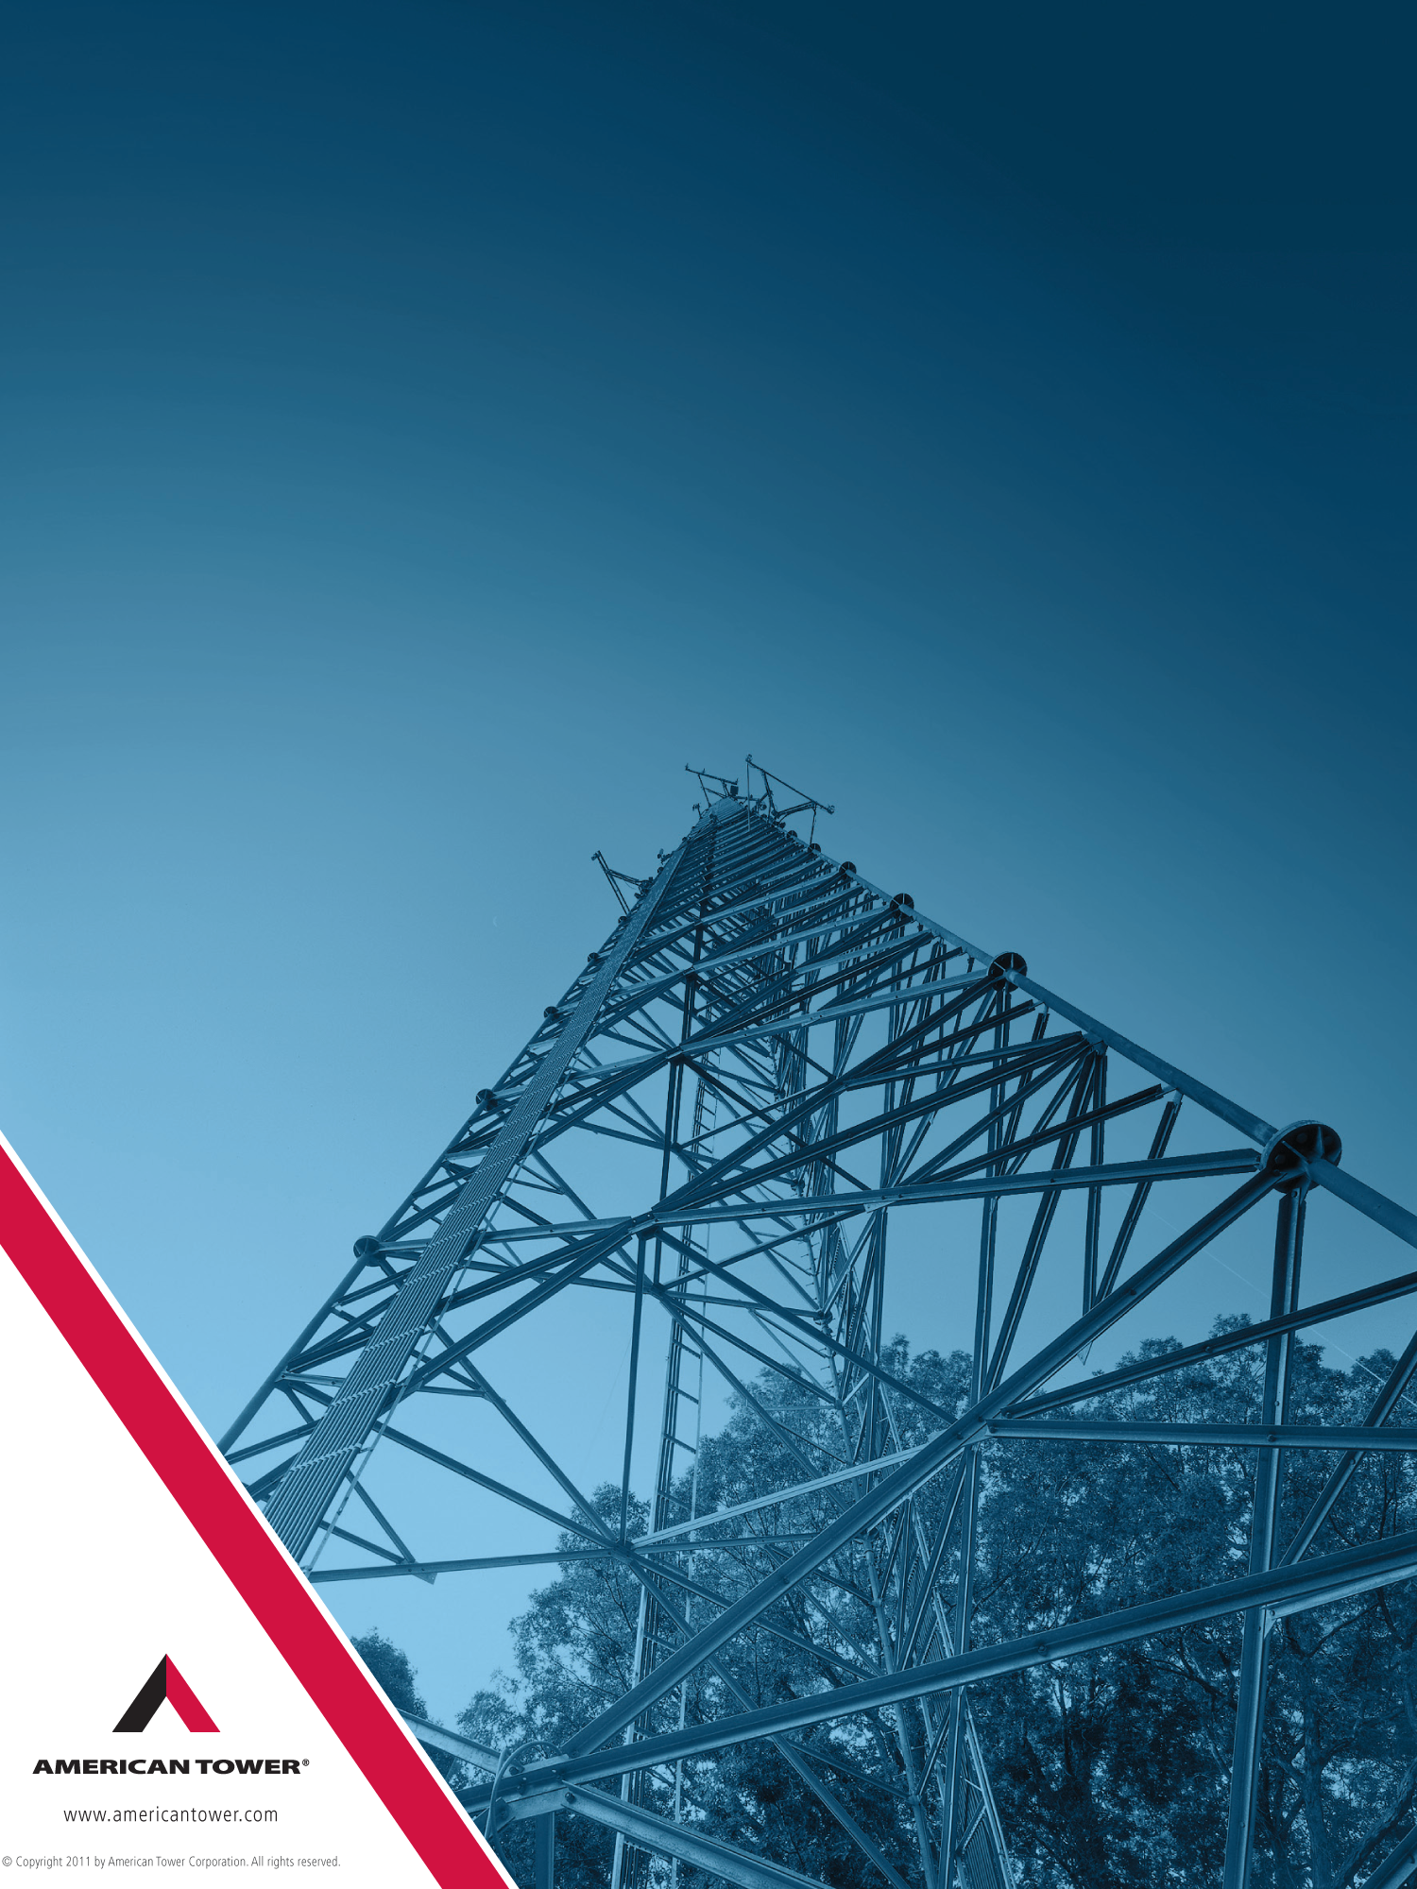

© Copyright 2012 by American Tower Corporation. All rights reserved.

April 12, 2016

Attn: Chilmark Selectmen

Chilmark Town Offices

401 Middle Road

P.O. Box 119 02535-0119

**RE: Menemsha Beach Wi-Fi**

Dear Selectmen,

Over the last few months, American Tower and our partners have explored different technical approaches to providing a low-cost easily scalable beach Wi-Fi. During the course of this research ATC was able to develop a potentially viable solution. We are very excited about the potential to trial this solution at Menemsha Beach.

American Tower and our partners would like to work with the Town of Chilmark to trial this unique network deployment method that integrates core town functions with telecom infrastructure. By using the TelecomTrash Stations, ATC can offer commercial grade Wi-Fi to beach goers, boaters and the town while being able to provide additional non-telecom benefits to Chilmark. This joint partnership trial could accelerate real commercial deployments by introducing cost savings, revenue sharing opportunities, and subsidized services to municipalities.

American Tower is prepared to make a $100,000 investment that includes the time and material for Wi-Fi enabled TelecomTrash Stations at Menemsha Beach. Although we will be collecting minimal revenue, we do not expect to see a return on the trial investment. This project is solely a proof of concept. We selected Menemsha beach for this investment not only because of its unique location, but because of the forward thinking town and the relationships we have been able to develop through our DAS interactions.

Based on the Town of Chilmark BOS meeting dated 03.08.16 ([www.mvtv.org](http://www.mvtv.org)) I would submit the following to address your concerns.

ATC believes the Town of Chilmark will find this proposal compelling for the following reasons:

* **Potential Town Revenue:** American Tower will provide the Wi-Fi for free to any user for the first year of the trial. After the first year ATC will provide the Town of Chilmark with a detailed accounting of any revenue generated from the Wi-Fi to ensure the town that ATC is not making a return on the $100K investment. At the end of a 24 month trial, American Tower will enter into direct negotiations with the town to assign an appropriate monthly fee based on the revenues. Again, this is a trial that will benefit both the town and ATC
* **Beach Aesthetics:** American Tower is committed to work with the town for the right look of the TelecomTrash Stations. The trash stations have been placed into historic areas with photographic wraps that replicate any type of look and/or feel. Please see the photograph at the end of the document for a sample solution.
* **Town Cost Savings (Labor & Vehicle Efficiency):** Servicing your public space waste & recycling locations is one of the most resource intensive operations your town can face. You can either over-collect to ensure there are no problem areas or roll the dice and hear the complaints when overflows and litter problems plague an area. Labor and fuel savings will come from optimized collection operations, our customers have realized. American Tower will provide 4 TelecomTrash Stations at no cost to the town. The town will be able to trial this system at no cost.
* **Reduction of Critters**: The enclosed TelecomTrash Stations design eradicates many animal-related issues. Seagulls and other birds are not extracting trash and rodents of all kinds — from squirrels to rats — are barred access from the containers, which has in some cases reduced their overall population in areas where the solution has been deployed. Bees and other insects are denied access, too, keeping them from building nests and stinging visitors and citizens. Even bears are unable to access the waste contents due to the unique hopper design.
* **Sustainability:** The Bigbelly Smart Waste & Recycling System is a platform to communicate with your constituents about your environmental programs. Customizing stations with wraps and/or message panels provides a unique branding opportunity for your sustainability initiatives. The recycling offerings and solar panels provide the perfect opportunity for community engagements.

American Tower is very excited to trial the first ever beach TelecomTrash Stations with the Town of Chilmark. We feel it will be an exciting time for ATC and Chilmark to test out these services at no risk to either party.

I look forward to the opportunity to work with Town of Chilmark on this project. Should you have any questions, please do not hesitate to contact me, +1 (919) 8008838 office or [david.fox@americantower.com](mailto:david.fox@americantower.com).

Very truly yours,

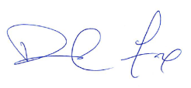

David Fox  
Director of Business Development – Managed Sites

